GPSM InterShare EDMS

Windows InterShare Client Installer Installation User Guide

Pre-Requisite :
- Internet ready
- PC Workstation for Sca

Step | Description
1 | Download Windows InterShare Client Installer from http:://xxx.brother.xxx website  SCREEN SHOT THE DOWNLOAD PAGE  Important :  How can I tell if my computer is running a 32-bit or a 64-bit version of Windows?  To find out if your computer is running a 32-bit or 64-bit version of Windows  in Windows 7/10 or Windows Vista, do the following:  - Open System by clicking the Start button , right-clicking Computer, and then clicking  Properties.  - Under System, you can view the system type.If your computer is running Windows  XP, do the following:  - Click Start.  - Right-click My Computer, and then click Properties.  If you don't see "x64 Edition" listed, then you're running the 32-bit version of Windows  If "x64 Edition" is listed under System, you're running the 64-bit version of Windows
2 | Go to download folder, right clicking on InterShareClient_32bit.exe or InterShareClient_64bit.exe and run as Administrator.  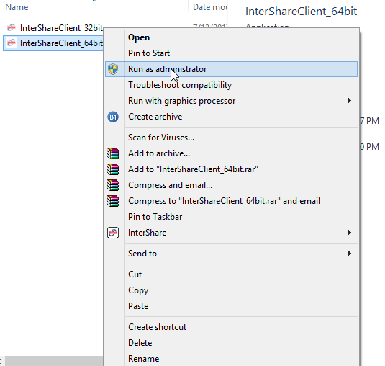
3 | Click OK to select English Language  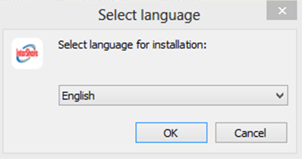
4 | Click Next to Continue  Note : Do not change the default path.  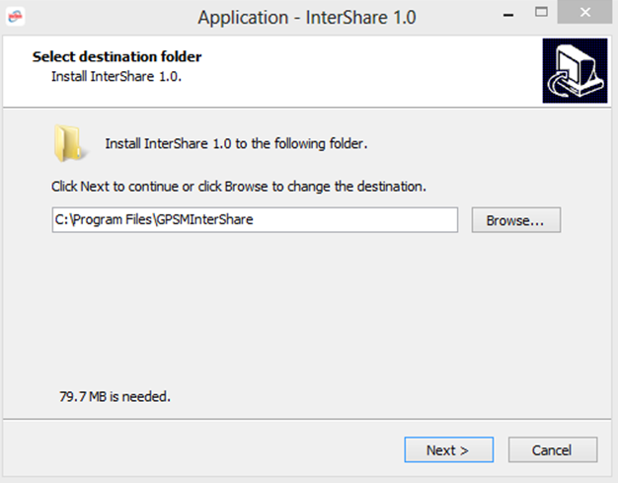
5 | Click Install to Continue  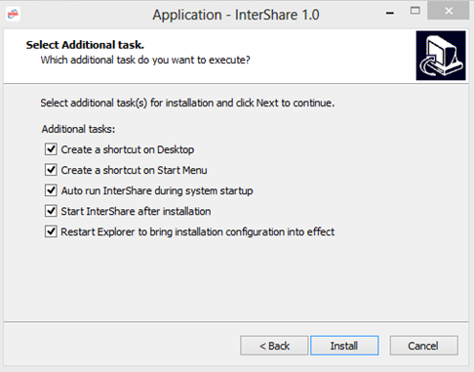
6 | Click Next to Continue  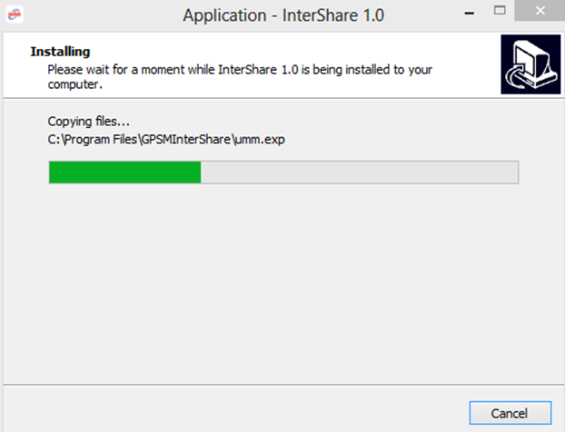
7 | InterShare Windows Client Software Popup  Note : Refer to <brother purchase email> for the USER ID and PASSWORD  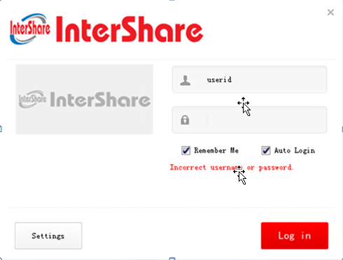
8 | Click on Settings to configure EDMS InterShare Network Settings  Note : Enter “edms.intershare.asia” in Server address field.  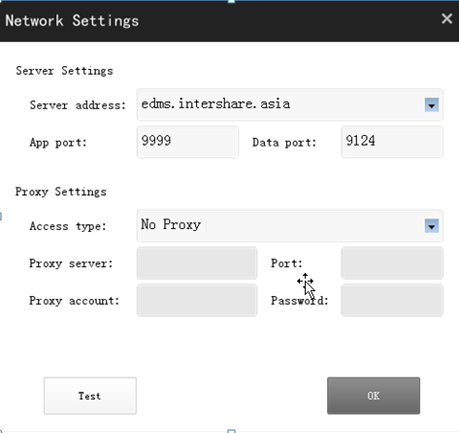  Click on Test Button to test the connectivity  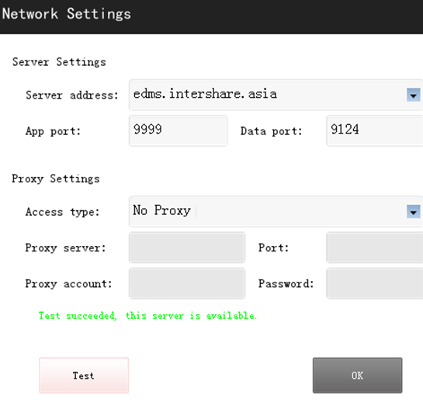
9 | Configure InterShare EDMS path (Destination Folder) in Control Center 4. Enter “C:\InterShare\<UserName>” in Destination Folder under OCR button.  Note :  Open Control Center 4, Refer to Brother Support Document for Control Center 4 installation.  